UPGRADE INSTRUCTIONS

Backups
Very important
Before doing the upgrade, you need to make a backup of the existing data
How to make a backup:
Click on Maintenance
13 – Network Backup
This screen will open:
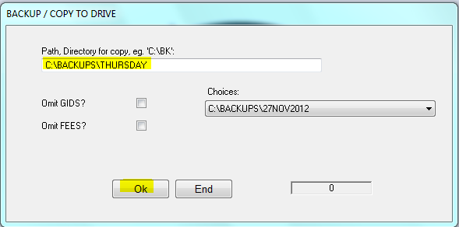

Enter drive and folder path where for backups eg. C:\ (for your own computer hard drive) you can also change this to the network drive or external hard drive
type folder – you can type any folder name. The system will create the folder, even if it doesn’t exist
Click op OK
The counter at the bottom will start to run and stop when done

Make sure the backup is there in the folder specified
Go to my Computer, open the backup folder specified and make sure the txt files (data files) are in this folder with the date you’ve done the backup:
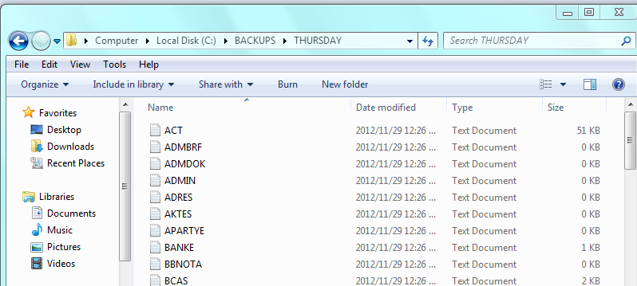

If backup is done and correct, you can proceed with the upgrade

- Lexpro Website
Make sure all Lexpro users are logged out all Lexpro programs
Go to Internet
In address, type: www.lexpro.co.za
The Lexpro homepage will appear
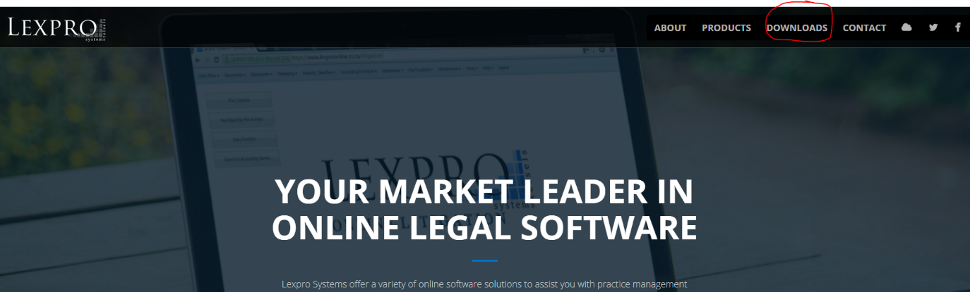
- Download Upgrades
To upgrade, click on Downloads
Select file you want to upgrade, eg. Accounting:
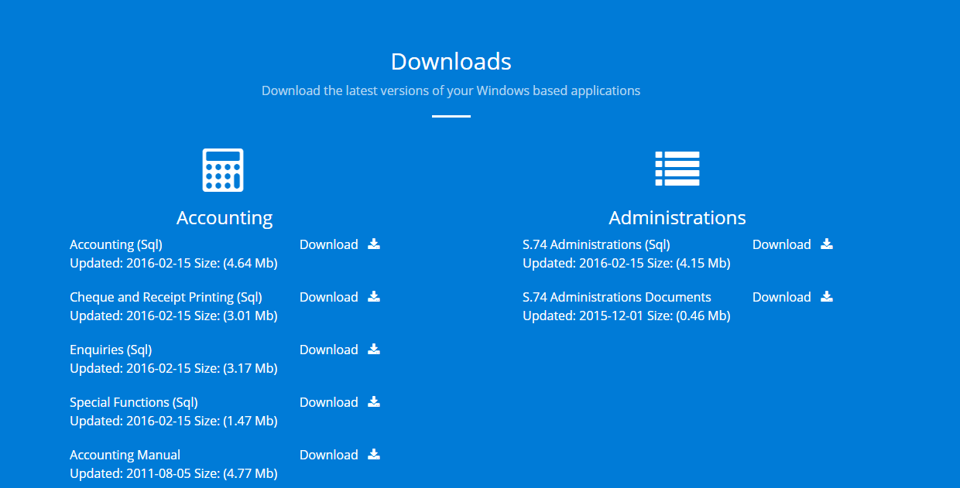
Click Accounting (SQL), the file will start with download and will appear in the taskbar
Choose next program to upgrade, eg. Litigation
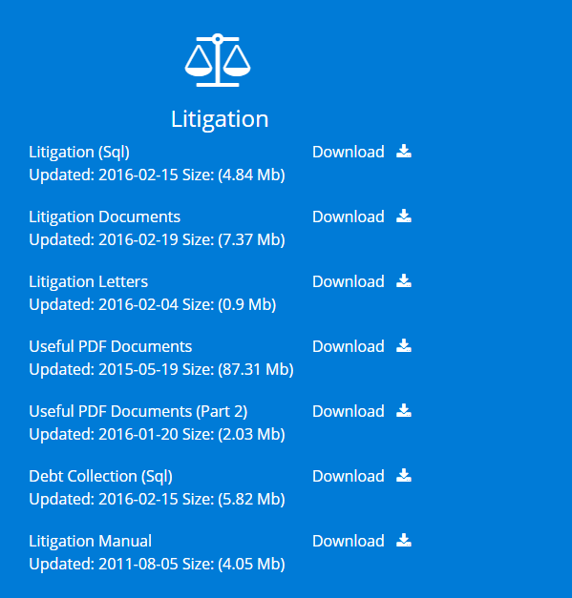
Click Litigation (SQL) first to download program
After downloaded, choose Lexpro Litigation Documents to download documents
After document download, choose Lexpro Litigation Letters to download letters
All downloaded files will be in the taskbar or the folder where you specified to download

- Extract downloads
Click on the file that you downloaded
Accounting will be swb1.zip
Litigation will be swl1.zip
Litigation documents will be srtf.zip
Litigation letters will be sbrf.zip
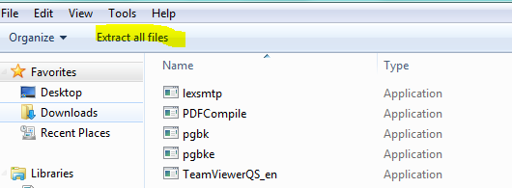

If you click on the zip file, the list of all encrypted files will appear
Click on Extract files
A destination path and Browse button will appear – click on Browse and choose folder to extract files
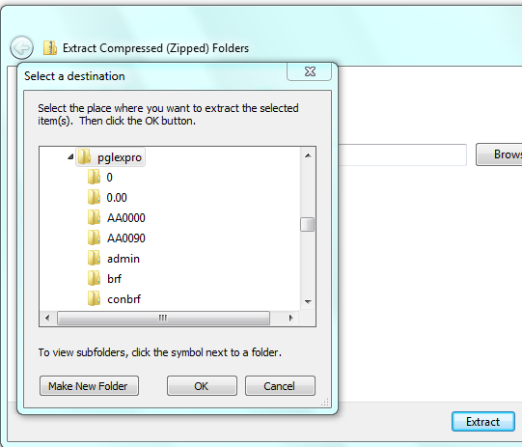

If you don’t know where files should be extracted to – go back to your desktop
Right click on the Lexpro program’s icon that you want to update
Click on properties
The following screen will appear:
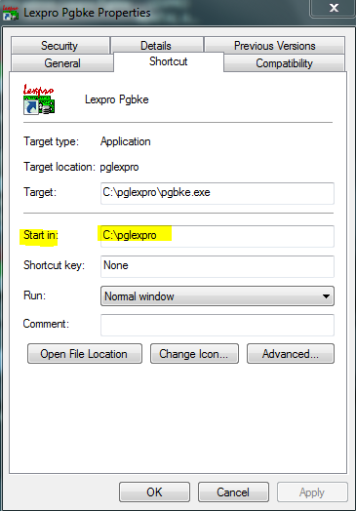
The ‘Start in” folder, is the folder where the files should be extracted to, eg. C:\Pglexpro
Go back to extract files and browse to the folder as in your ‘Start in”, and click OK
- Password
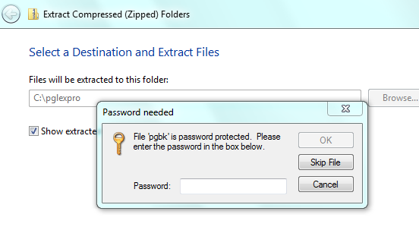
The system will now ask for a password
This password will be given to you by your Lexpro Consultant – please phone or email to obtain password
Enter password and click on Extract all
The system will warn that Files already exist, you need to copy and replace files
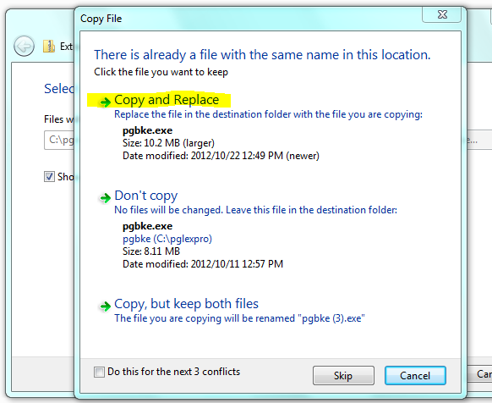
Do this with all files downloaded that you want to upgrade
Litigation court documents must be extracted to the RTF folder in your Lexpro folder
Litigation letters should be extracted to the BRF folder in the lexpro folder

- After upgrade
When upgrade is complete – go in the Lexpro program
Click on Maintenance, Click on Create tables
Click on Maintenance again - click amend fields
After tables created, Click on Maintenance again, Click on Build Indexes

